[Finance and economics](https://www.economist.com/finance-and-economics/) | Consumerzzzzzzzzz

Welcome to the age of the hermit consumer

欢迎来到隐士消费的时代

The world economy is witnessing a $600bn-a-year shift in behaviour

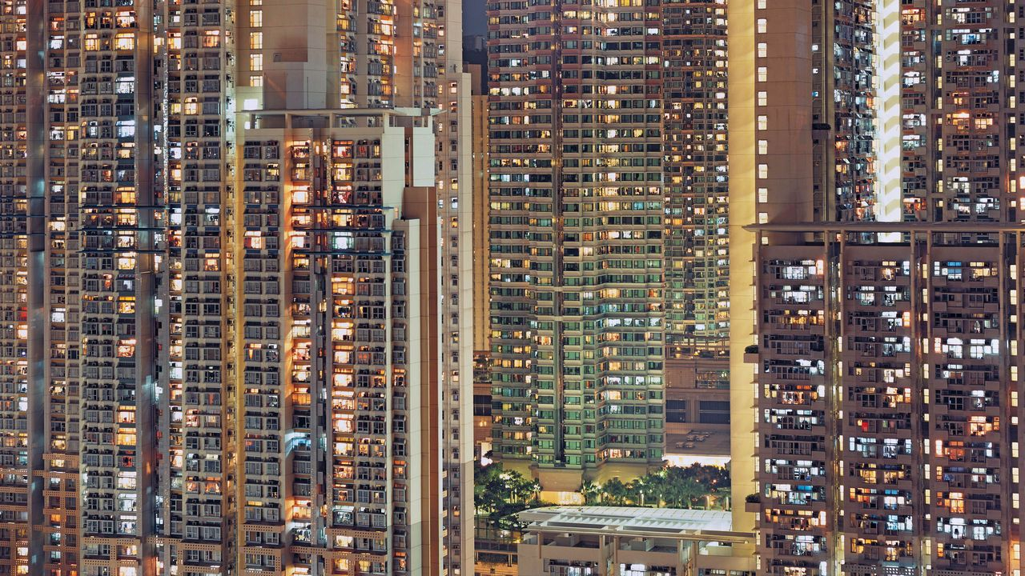

image: michael wolf estate/laif/camera press

Oct 22nd 2023 | SAN FRANCISCO

In some ways the covid-19 pandemic was a blip. After soaring in 2020, unemployment across the rich world quickly dropped to pre-pandemic lows. Rich countries reattained their pre-covid gdp levels in short order. And yet, more than two years after lockdowns were lifted, at least one change appears to be enduring: consumer habits across the rich world have shifted decisively, and perhaps permanently. Welcome to the age of the hermit.

从某些方面来说，covid-19的流行只是昙花一现。富裕国家的失业率在2020年激增后迅速降至新冠大流行前的最低点。富裕国家的国内生产总值在短时间内恢复到新冠疫情前的水平。然而，在解除封锁两年多后，至少有一项变化似乎是持久的：富裕国家的消费者习惯已经发生了决定性的、甚至可能是永久性的改变。欢迎来到隐士消费时代。

In the years before covid, the share of consumer spending devoted to services rose steadily upwards. As societies got richer, they demanded more in the way of luxury experiences, health care and financial planning. Then, in 2020, [spending on services](https://www.economist.com/graphic-detail/2020/04/09/how-the-covid-19-pandemic-is-changing-americans-spending-habits), from hotel stays to hair cuts, collapsed owing to lockdowns. With people spending more time at home, demand for goods jumped, with a rush for computer equipment and exercise bikes.

在新冠疫情爆发之前的几年里，用于生活服务的消费者支出比例稳步上升。随着社会变得更加富裕，他们对奢侈体验、医疗保健和财务规划的要求越来越高。然后，到了 2020 年，由于封锁，从酒店住宿到理发等服务支出大幅下降。随着人们呆在家里的时间越来越多，对商品的需求猛增，对电脑设备和健身自行车的需求也随之增加。

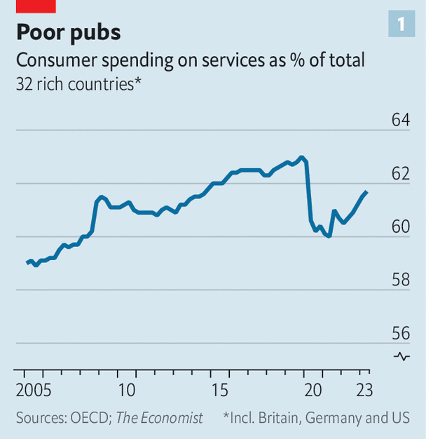

Three years on the share of spending devoted to services remains below its pre-covid level (see chart 1). Relative to its pre-covid trend, the decline is even sharper. Rich-world consumers are spending on the order of $600bn a year less on services than you might have expected in 2019. In particular, people are less interested in spending on leisure activities that generally take place outside the home, including hospitality and recreation. The money saved is being redirected to goods, ranging from durables such as chairs and fridges, to things like clothes, food and wine.

三年来，用于生活服务的支出比例仍低于疫情前的水平（见图 1）。与新冠疫情爆发前的趋势相比，下降幅度更大。 2019 年，富裕国家的消费者每年在服务上的支出比预期的要少 6000 亿美元。特别是，人们对在一般在户外且需要支出的休闲活动（包括招待和娱乐）不太感兴趣。这样节省下来的钱又被用于购买商品，涵盖从椅子和冰箱等耐用品到衣服、食物和酒等物品。

In countries that spent less time in lockdown, hermit habits have not become ingrained. Spending on services in New Zealand and South Korea, for instance, is in line with its pre-covid trend. Elsewhere, though, hermit behaviour now looks pathological. In the Czech Republic, which was whacked by covid, the services share is about three percentage points below trend. America is not far off. Japan has witnessed a 50% decline in restaurant bookings for client entertainment and other business purposes. Pity the drunk salaryman staggering around Tokyo’s entertainment districts: he is now an endangered species.

在疫情上管控时间较短的国家，隐性消费习惯尚未根深蒂固。例如，新西兰和韩国的生活服务支出与新冠疫情前的趋势在同一水平。然而，在其他地方，隐士消费行为现在看起来是病态的。在遭受新冠疫情重创的捷克共和国，服务业份额比大众趋势水平低约三个百分点。美国也并没有多很多。日本用于客户娱乐和其他商业目的上的餐厅预订量下降了 50%。可怜那些在东京娱乐区摇摇晃晃的醉酒上班族：他现在是濒临灭绝的物种

At first glance, the figures are hard to reconcile with the anecdotes. Isn’t it harder than ever to get a reservation at a good restaurant? And aren’t hotels full of travellers, causing prices to soar? Yet the true source of the crowding is not sky-high demand, but constrained supply. These days fewer people want to work in hospitality—in America total employment in the industry remains lower than in late 2019. And the disruption of the pandemic means that many hotels and restaurants that would have opened in 2020 and 2021 never did. The number of hotels in Britain, at around 10,000, has not grown since 2019.

乍一看，这些数字很难与轶事相符。预订一家好餐厅是不是比以往更难了？酒店不是人满为患，导致物价飞涨吗？然而，拥挤的真正根源并不是需求过高，而是供应有限。如今，想要在酒店业工作的人越来越少——在美国，该行业的总就业人数仍然低于 2019 年底。而疫情的破坏意味着许多本应在 2020 年和 2021 年开业的酒店和餐馆从未开业。英国的酒店数量约为 10,000 家，自 2019 年以来一直没有增长。

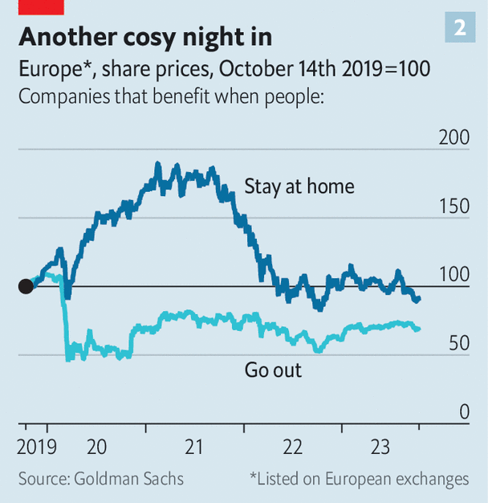

Firms are noticing the $600bn shift. In a recent earnings call an executive at Darden Restaurants, which runs one of America’s finest restaurant chains, Olive Garden, noted that, relative to pre-covid times, “we’re probably in that 80% range in terms of traffic”. At Home Depot, which sells tools to improve your home, revenue is up by about 15% on 2019 in real terms. Investors are noticing. Goldman Sachs, a bank, tracks the share prices of companies that tend to benefit when people stay at home (such as e-commerce firms) and those that thrive when people are out and about (such as airlines). Even today, the market looks favourably upon firms that service stay-at-homers (see chart 2).

企业们注意到了 6000 亿美元的转变。在最近的一次财报电话会议上，达登餐厅 (Darden Restaurant) 的一位高管指出，与新冠疫情爆发前相比，“就客流量而言，我们可能在之前的80%氛围内”。该公司经营着美国最好的连锁餐厅之一橄榄园 (Olive Garden)。家得宝 (Home Depot) ，一家销售改善家居的工具的公司，其实际收入比 2019 年增长了约 15%。投资者注意到。高盛银行关注那些 在人们居家时受益的公司（例如电子商务公司）和那些当人们外出时会蓬勃发展的公司（例如航空公司）的股价。即使在今天，市场仍然看好为居家者提供服务的公司（见图 2）。

Why has hermit behaviour endured? The first possible reason is that some tremulous folk remain afraid of infection, whether by covid or something else. Across the rich world people are swapping crowded public transport for the privacy of their own vehicles. In Britain, car use is in line with the pre-covid norm, whereas public-transport use is well down. People also seem less keen on up-close-and-personal services. In America spending on hairdressing and personal-grooming treatments is 20% below its pre-covid trend, while spending on cosmetics, perfumes and nail preparations is up by a quarter.

为什么隐士消费行为能够持续存在？第一个可能的原因是，一些胆怯的人仍然害怕感染，无论是新冠病毒还是其他原因。在富裕国家，人们正在将拥挤的公共交通换成拥有私密空间的私人车辆。在英国，汽车使用量与新冠疫情爆发前的是使用量一致，而公共交通的使用量则大幅下降。人们似乎也不那么热衷于近距离的个性化服务。在美国，美发和个人美容护理方面的支出比新冠疫情爆发前的比例低 20%，而化妆品、香水和指甲护理用品方面的支出则增长了四分之一。

The second relates to [work patterns](https://www.economist.com/business/2022/12/01/the-open-questions-of-hybrid-working). Across the rich world people now work about one day a week at home, according to Cevat Giray Aksoy of King’s College London and colleagues. This cuts demand for the services bought when at the office, including lunches, and raises demand for do-it-yourself goods. Last year Italians spent 34% more on glassware, tableware and household utensils than in 2019.

第二个与工作模式有关。伦敦国王学院的塞瓦特·吉雷·阿克索伊 (Cevat Giray Aksoy) 及其同事表示，在富裕国家，人们现在每周大约一天在家工作。这减少了需要在办公室购买的服务（包括午餐）的需求，并增加了对自助商品的需求。去年意大利人在玻璃器皿、餐具和家庭用具上的支出比 2019 年增加了 34%。

The third relates to values. The pandemic may have made people genuinely more [hermit-like](https://www.economist.com/graphic-detail/2023/06/28/sunday-brunch-is-the-new-friday-night). According to official data from America, last year people slept about 11 minutes more than they did in 2019. They also spent less on clubs that require membership and other social activities, and more on solitary pursuits, such as gardening, magazines and pets. Meanwhile, global online searches for “Patience”, a card game otherwise known as solitaire, are running at about twice their pre-pandemic level. Covid’s biggest legacy, it seems, has been to pull people apart.

第三个与价值观有关。这场流行病可能让人们真正变得更像隐士。根据美国的官方数据，去年人们的睡眠时间比 2019 年多了约 11 分钟。他们在需要会员资格的俱乐部和其他社交活动上的花费也有所减少，而更多地花在园艺、杂志和宠物等独处活动上。与此同时，“耐心”（一种纸牌游戏，也称为纸牌游戏）的全球在线搜索量约为大流行前水平的两倍。看来，新冠疫情最大的遗产就是让人们变得疏远。